|  |  |
| --- | --- |
| JU Mess | Version 1.0 |
| Support android version 4.0 or greater | 10/01/2018 |
| Dexter |  |

Dexter

**JU-Mess**

**Software Requirement and Specification**

Version 1.0

**Team Guide:** Ravi Shankar Sir

**Members:** Shubham Dhanuka

Mukul Chippa

Anish Chauhan

Akshay Bengani

Sachin Maheshwari

Deepesh Bansal

College Name: JECRC University

Department: Information Technology

State: Rajasthan

Dexter/ <JECRC University> Page 1

|  |  |
| --- | --- |
| JU Mess | Version 1.0 |
| Support android version 4.0 or greater | 10/01/2018 |
| Dexter |  |

**Revision History**

|  |  |  |  |
| --- | --- | --- | --- |
| **Date** | **Version** | **Description** | **Author** |
| 10/01/2018 | 1.0 | Synopsis | Dexter |
| 10/01/2018 | 2.0 | Synopsis | Dexter |
|  |  |  |  |

Dexter/ JECRC University Page 2

|  |  |
| --- | --- |
| JU Mess | Version 1.0 |
| Support android version 4.0 or greater | 10/01/2018 |
| Dexter |  |

**Table of Contents**

**Description** **Page**

**1.0 Introduction** **No.**

* + 1. Purpose 4
    2. Scope 4
    3. Definition, Acronyms, and Abbreviations 4
    4. References 5
    5. Technologies to be used 6
    6. Overview 7

1. **Overall Description 8**
   1. Product Perspective 8
   2. Software Interface 8
   3. Hardware Interface 9
   4. Product Function 9
   5. User Characteristics 9
   6. Constraints 9
   7. ER Diagram 9

Dexter/ JECRC University Page 3

|  |  |
| --- | --- |
| JU Mess | Version 1.0 |
| Support android version 4.0 or greater | 10/01/2018 |
| Dexter |  |

1. **Specific Requirements** 
   * 1. Use Case Reports
     2. Supplementary Requirements

Dexter/ JECRC University Page 4

|  |  |  |
| --- | --- | --- |
|  |  |  |
| JU Mess |  | Version 1.0 |
| Support android version 4.0 or greater |  | 10/01/2018 |
| Dexter |  |  |

**Software Requirement Specification**

1. **Introduction:**

App is designed to lubricate the work flow of mess.

1. Purpose:

* The app is designed to list food menu 2 hours before meal time.
* It provides convenience of information.
* It is mainly purposed to provide dish feedback on a single platform
* It helps mess team to let them know how many students are interested to come or go outside.

1. Scope: The Scope of the JU Mess includes:

* Reducing the efforts of both student and faculty at JU Mess.
* To ensure good quality food
* To improve taste and hygiene of food.

1. Definitions, Acronyms, and Abbreviations:

* XML (Extensible Markup Language): It is a markup language that was designed to transport and store data.
* JAVA: It is programming language use to build up logical functioning of the app.
* FIREBASE: It is a middle ware developed by google for supporting the backend work of app.
* ANDROID STUDIO: It is android app creating software by google which integrate XML, JAVA and DATABASE

Dexter/ JECRC University Page 5

|  |  |  |
| --- | --- | --- |
|  |  |  |
| JU Mess |  | Version 1.0 |
| Support android version 4.0 or greater |  | 10/01/2018 |
| Dexter |  |  |

1. References:

<https://firebase.google.com/docs>

<https://developer.android.com/reference/classes.html>

<https://classroom.udacity.com/courses/ud0352>

<https://www.youtube.com/playlist?list=PLwjDFmCyhIJAvRto5FxDnky7VVaXIAAYa>

Dexter/ JECRC University Page 6

|  |  |  |
| --- | --- | --- |
|  |  |  |
| JU Mess |  | Version 1.0 |
| Support android version 4.0 or greater |  | 10/01/2018 |
| Dexter |  |  |

1. Technologies to be used:

* **J2EE:** ( Servlet, JSP, JAXP, Java Beans) Application architecture.
* **JAVA:** Application architecture.
* **WASCE:** (WebSphere Application Server Community

Edition) Web Server

* **DB2:** IBM Database.
* **Ajax:** Asynchronous Java Script and XML.
* **XML:** Extension Markup Language.

**Web 2.0:** RSS Feed 2.0.

* **RAD 7.0:** Development tool.
* **Localization:** 3 Languages – Hindi and English
* **FireBase:** Backend management

Dexter/ JECRC University Page 7

|  |  |  |
| --- | --- | --- |
|  |  |  |
| JU Mess |  | Version 1.0 |
| Support android version 4.0 or greater |  | 10/01/2018 |
| Dexter |  |  |

1. Overview: The SRS will include two sections, namely:

-I- **Overall Description:** This section will describe major components of the system, interconnections, and external interfaces.

-I- **Specific Requirements:**This section will describe the

functions of actors, their roles in the system and the constraints faced by the system.

1. **Overall Description:**
2. Product Perspective:
   * Enter the product perspective >
3. Software Interface:

-I- **Front End Client:** Android

-I- **Web Server: Firebase**

-I- **Data Base Server: Firebase**

4- **Back End: Firebase**

Dexter/ JECRC University Page 8

|  |  |
| --- | --- |
| JU Mess | Version 1.0 |
| Support android version 4.0 or greater | 10/01/2018 |
| Dexter |  |

**2.3** Hardware Interface:

4- **Client Side: Android Device**

4- **Server Side: Google Firebase**

* + 1. Product Functions:.

List Food Menu before meal time, Accept Feedback from users about particular food, A user can also register a complaint specially for a particular item.

* + 1. User Characteristics: User will use a Android Device and all the working of App is done from a Firebase Server all the Dynamic operations are handled by firebase.
       - 1. Constraints:

Its only for Android Platform, Required Internet

* + - * 1. ER Diagram:

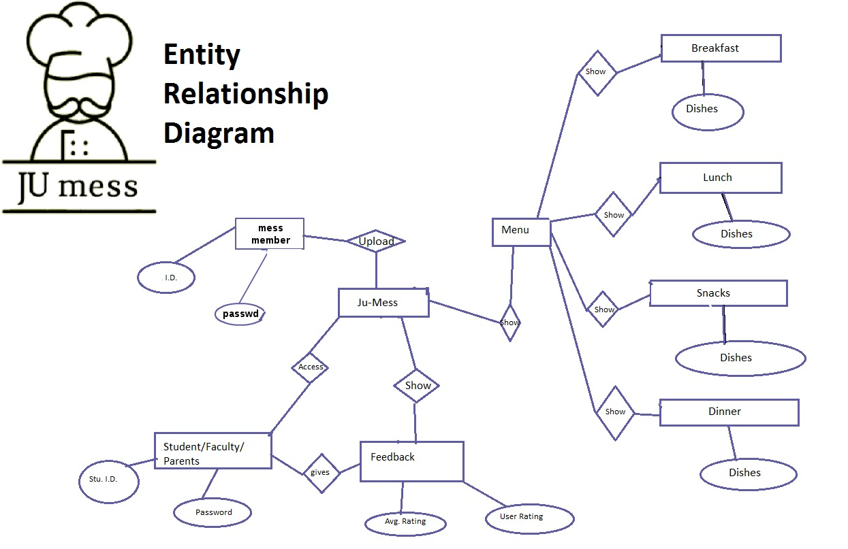

1. **Specific Requirements:** 
   1. **Use Case Reports:**
   2. **Supplementary Requirements:**

Dexter/ JECRC University Page 9